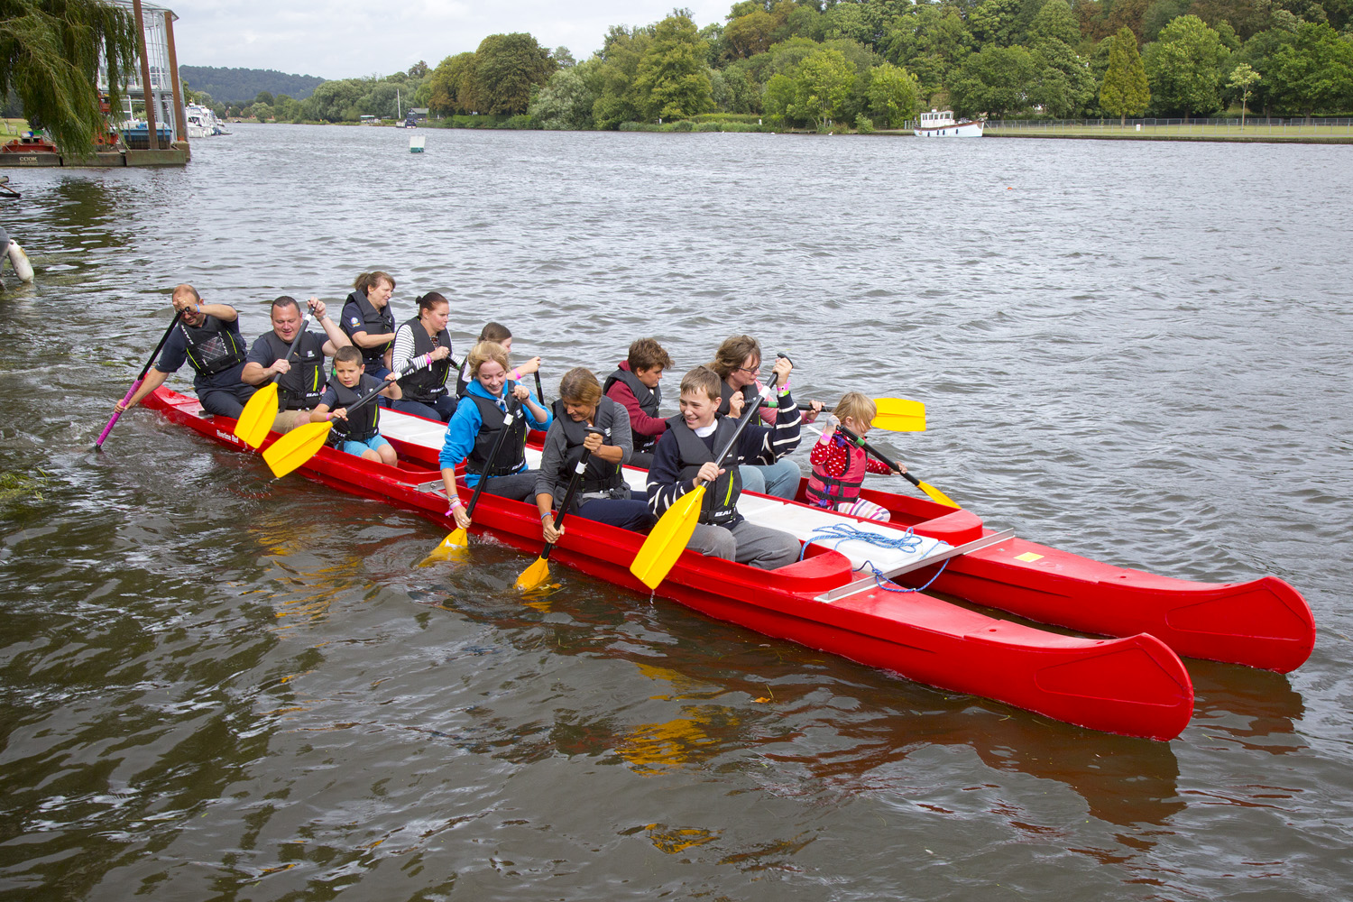

Whether this is your first journey into uncharted waters or you are an experienced paddler, this guide aims to ensure you are ship-shape and sea-worthy for the challenge ahead. Entering this spectacular event really couldn’t be simpler! All you need to do is read this information pack and return the entry form on page 6 to Regatta for the Disabled.
Please read all of the following carefully before completing the entry form.
Questions
What experience do I need to take part? Each team will be given a full briefing on the day of how to paddle and handle a Bell Boat – so previous experience is not necessary!

How many people do I need for a team? Bell Boats accommodate teams of 10 paddlers and our qualified helm (the minimum number in a boat is 6 paddlers). The helm will be provided. We suggest you recruit crews of up to 13 for your team, although a maximum of only 10 crew members will race in the boat at one time, there will be plenty of opportunity to rotate the crew members during the Regatta. We ask that at least 2 of your crew paddling in each race has a disability. If this is not possible then a 10 second time penalty will be incurred when racing against a team who meet that criterion.

What is the minimum age to take part? The minimum age in a team is 8 years. For participants under the age of 18 years the adult responsible will be required to countersign the declaration form on their behalf following the safety briefing.

Can I bring supporters? We would be delighted to welcome friends and family to encourage you. Tickets will be available on the day of the event at £5 each.
Terms & Conditions of Entry
Water Confidence - All team members must be able to swim in light clothing.
Safety - The safety of a Bell Boat crew on the water is the prime concern of everyone associated with the event. However, the event is an adventure sport and as such involves a risk of injury regardless of the standard of training, supervision and equipment involved. Each participant will be required to sign the team declaration sheet following their safety briefing on the race day and given a green wrist band. By signing the team sheet each participant voluntarily accepts all risks involved and will not hold Regatta for the Disabled liable for any claims arising from any accident resulting in any loss or damage including bodily injury or death. All competitors must wear a buoyancy aid provided by Regatta for the Disabled when on the water.
Alcohol - Consumption of alcohol by any participant is strictly prohibited until racing has finished. Any participant who is thought to have consumed alcohol or is not in a 'fit state' to participate will not be allowed to race and their green wristband will be removed. The unlawful use of any banned substance is not permitted at any time.
Medical Restrictions - Each participant must be reasonably fit, able to swim in light clothing and not vastly overweight to their height. If you are unsure whether you can take part please seek your doctor's advice.
Entry Fees – Minimum donation is £100.00 per team. Teams may consist of a maximum of thirteen and a minimum of seven members. Full payment is required to guarantee entry into the event, please see the entry form on page 6 for payment details.

Postponement/Cancellation – Regatta for the Disabled will take all reasonable steps to ensure that racing takes place as specified in this information pack. Regatta for the Disabled do however reserve the right to delay, postpone or cancel the Regatta in the event of adverse weather conditions or other events outside of the organisers’ control. The determination of what constitutes this is reserved by Regatta for the Disabled. Entry fees are non-refundable, non-deferrable and non-transferable, even in the case of event cancellation.

Bell Boat Regatta Information
Racing Format - Every team can expect to take part in a minimum of three races with the fastest teams going through to the semi finals and the winner of each semi-final progressing to the final. The race programme will be available on the day

Racing Class- Teams may be made up of male and or female paddlers (any ratio).

Times
10.00 am | Crew registration & Safety Briefings
10.30 am | First race
Break | Expect there to be a break in racing between the end of the heats and the first semi-final
2.00 pm | First semi-final
2.30 pm | Final
3.30 pm | Presentation

Registration on the Day - The Team Manager must register at Regatta for the Disabled Race Control on arrival and collect the teams race pack for the day. NO other team members are required to register at Race Control but all team members must be on site at the registration time they have been allocated for their safety briefing before racing commences. Any late comers will be unable to race as it is unlikely that there will be the opportunity for additional briefings once racing has started!

Team Lists - Each team member will be asked to sign a team list on completion of the safety briefing. On signature each team member will be given a green wrist band to wear for the duration of the day, this confirms they have received the briefing and have signed the team list. No green band = no racing!

Clothing - We recommend that you bring a complete change of clothing and a towel. You should wear light clothing such as shorts, jogging trousers, t-shirt or sweatshirt and a pair of old trainers. Your feet will get wet, so don’t wear your most expensive pair! Changing facilities will be available.
No jeans, wellingtons, heavy footwear or ostentatious jewellery.

Prizes - Prizes will be awarded to: 1st, 2nd Place Overall, also for the most enthusiastic team.

Rules & Regulations - Detailed rules and regulations are outlined on page 5 of this pack.

PLEASE LISTEN CAREFULLY TO & FOLLOW ANY INSTRUCTIONS GIVEN TO YOU
BY MEMBERS OF THE ORGANISING COMMITTEE & REGATTA FOR THE DISABLED STAFF

Venue Information

Car Parking - Free car parking is available in the field opposite Phyllis Court Club entrance, please ensure that you park neatly and follow the directions given to you by attendants. Cars are parked at owner’s risk, FOUR CARS ONLY PER TEAM PLEASE. Cars with a blue disabled badge may park at Phyllis Court paddock but space is limited so please park in the field opposite if possible.

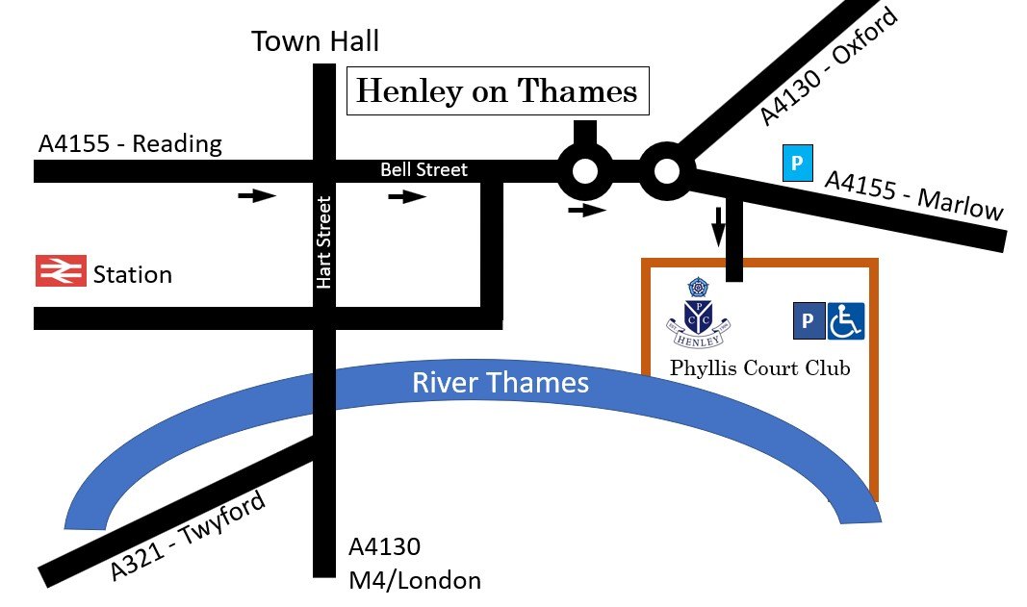
Directions to the Venue
From London, M4: Leave motorway at exit 8/9 onto the A404(M) following the signs for Henley on Thames. Straight over roundabout onto A4130 into town centre. Go over the bridge and turn right at lights. Go straight over the first mini-roundabout and fork right at the next onto A4155 to Marlow. After 150 metres turn right into Phyllis Court Drive to the Phyllis Court Club.
From London, M40 and High Wycombe: Leave motorway at exit 4 onto the A404(M). Follow the signs for Henley on Thames taking the A4130. Thereafter as above.
From Oxford: Take the A4130 through Nettlebed to Henley on Thames. Continue to mini-roundabout, turn left onto A4155 to Marlow, and after 150 metres turn right into Phyllis Court Drive to the Phyllis Court Club.
From Maidenhead: To Thicket Corner and take A4130. Right at lights, then follow directions as from London.
From Basingstoke/Reading: Take the A4155 out of Reading into Henley town centre. Go straight over the traffic lights towards Oxford on A4130 to mini-roundabout. Fork right onto the A4155 to Marlow, and after 150 metres turn right into Phyllis Court Drive to the Phyllis Court Club.
Dogs - Guide Dogs and well-behaved dogs on a lead are allowed and owners must ensure mess is disposed off in the specified waste bins

BBQS - Are not allowed within the venue, in the car parks or anywhere else on the site.

Riverside Viewing Area – There is ample viewing space of the racing from the riverfront, which can be used by teams and supporters. However, please ensure that you do not encroach on the boat loading area.

Food and Drink - Hot and cold beverages and food will be on sale throughout the day. You may bring your own food and drink.

Entertainment – There will be additional entertainment including boat trips throughout the day.
RACING RULES AND REGULATIONS

COMPETITION FORMAT

TEAM CAPTAIN
Every team must nominate a Team Manager on their team list. The Team Manager has overall responsibility for the conduct and actions of the team. The Chief Official and other Race Officials will only communicate on official matters with the Team Manager.

PADDLES
Teams may use their own paddles, provided they conform to the design and dimensions laid down by the British Bell Boat Association. All paddle looms (shafts) must be of straight design. Paddles with a cranked (off set) design or loom are not permitted.

EXPERIENCE
The competition is open to all comers. Previous experience of Bell Boating is not necessary to enter a team, but all team members MUST BE WATER COMPETENT IN LIGHT CLOTHING. A responsible adult must supervise competitors under the age of 12 years old, when in a Bell Boat.

EQUIPMENT
All boats and necessary equipment will be provided.

BUOYANCY AIDS
All competitors must wear a buoyancy aid provided by the race organiser when on the water. Team members may not be allowed to race in their own buoyancy aid.

RACES
TEAMS
Teams are to consist of a maximum of 10 participants per race, the helm will be provided by ‘Regatta for the Disabled’. The minimum number of paddlers is six. Teams may race with less than 10 but the number in the boat at the finish of the race must be the same as at the start. Only the number of paddlers in the team may be reduced, the helm must be present in the boat throughout the race.

HELMS (steerers)
Regatta for the Disabled will arrange helms for each team.

EMBARKING
Teams must report to the boat marshalling area, when called forward by the chief boat marshal or over the public address. However, irrespective of any ‘call forward’, teams should report to the marshalling area at least 20 minutes before the race start time. Teams failing to report on time may be barred from taking any further part in the competition.

STARTS
Teams must be in the Bell Boats and be at the start area, at least 5 minutes before their start time. All races will be started without reference to absentees.

STARTING POSITION
The position of the Bell Boats on the start line shall be that the front most parts of the boats are aligned.

STARTING SIGNAL
When the starter is satisfied that all the boats are correctly aligned, the starter shall alert the teams by saying ‘ARE YOU READY’. When the starter is happy that all teams are ready the starter shall give the starting signal by shouting ‘ATTENTION’ followed by the word ‘GO’.

FALSE STARTS
If the starter considers there to be a false start they will immediately recall the teams by shouting STOP, STOP, STOP teams should stop paddling and return immediately to the start line.

FINISHES
A boat has finished the race when the foremost part of the boat crosses the finish line with the same number of participants in the boat as started the race. After finishing a race, each participating team must return immediately to the embarking area.

DISEMBARKING
After disembarking from the Bell Boat the team is responsible for the safe return of all paddles and buoyancy aids to the place designated by the boat marshal and for bailing out any water from their boat.

RACE CONTROL
Teams must paddle a straight line and keep within their allocated lane/line from the start to the finish of their race. It is forbidden to knowingly impede other boats. Helms will order their paddlers to ‘STOP PADDLING’ if a collision is imminent. Teams that do not stop paddling and cause a collision will be disqualified from the competition and may face a further ban from racing in the future. Any team that causes a boat to collide with another one whilst racing, or that damages a boat or paddles of another team, or that deliberately swamps or causes another boat or their own boat to capsize will be disqualified from the competition.

OFFICIALS
All the officials appointed for the competition are responsible to the Chief Official for the conduct of the races and for ensuring that the Rules and Regulations are fully complied with. Crews must follow the directions of the Race Officials at all times. Failure to do so may result in disqualification of the crew or participant/s concerned. The Chief Official’s decisions on all matters affecting the races are final.

SAFETY ON THE WATER
SAFETY
The safety of a Bell Boat team on the water is the prime concern of everyone associated with the event, not least of which are the team members who have a responsibility to conduct themselves properly, in both a competitive and social sense. All competitors are to attend their team safety briefing before racing commences, after which they will be issued with a green wrist band.

MEDICAL RESTRICTIONS
Each participant must be reasonably fit and able to swim in light clothing. There is a minimum age of 8 and not vastly overweight in relation to height. If you are unsure whether you can take part please seek your doctor’s advice. If you have any medical condition which the Race Organisers should be aware of, please speak to the Race Official before your first race of the day.

NO ALCOHOL
Consumption of alcohol by any participant is strictly prohibited until racing has finished. Any participant who is thought to have consumed alcohol or is not in a 'fit state' to participate will not be allowed to race and their green wrist band will be removed. The unlawful use of any banned substance is not permitted at any time.

NOTICE
The event is an adventure sport and as such involves a risk of injury regardless of the standard of training, supervision and equipment involved. Each participant will be required to sign the team sheet following their safety briefing on the race day. By signing the team sheet each participant voluntarily accepts all risks involved and is fit and able to swim as per the medical restrictions above and will not hold Regatta for the Disabled liable for any claims arising from any accident resulting in any loss or damage including bodily injury or death.

LEPTOSPIROSIS & WEILS DISEASE
It is stressed that Leptospirosis and Weils disease are both rare but can be caught by anyone engaged in a water sport. An infection of Leptospirosis resembles a cold and influenza infection in the initial stages. The incubation period is 4 - 10 days. If you show the above symptoms after taking part in a water sport activity, you should contact your doctor and tell him you have been participating in water sports and you suspect Leptospira infection. Level of risk - on average each year, 9 people contract Leptospirosis through the participation in water sports. The instances of infection are therefore very rare and its deterioration into Weil's disease even rarer. Weil's disease is, however a very serious illness which must be diagnosed and treated swiftly.

REDUCE YOUR RISK BY BEING AWARE!
PLEASE NOTE THAT RACING WILL NOT BE DELAYED FOR LATECOMERS

Please complete one entry form per team
Team name (maximum 20 letters)

Representing

Contact Name Team Manager

Address

Postcode

Tel (work) Tel (home)

Mobile Email

How did you hear about the event?

Payment: I enclose my donation of £100.00 for ten team members.

Payment on-line: Beneficiary: Regatta for the Disabled Sort Code: 60 10 35 Account number: 13144529
Reference: Team name
Cheques payable to: Regatta for the Disabled. Please note that payment is required to guarantee entry into this event
Declaration
By signing this entry form I confirm my wish to enter a team into this event and confirm that I have read, understood and undertake to be bound by the Racing Rules and Regulations as outlined on page five of this document. I understand that I should advise my team members to seek medical advice from their general practitioner if they are in any doubt as to their physical ability to take part in this event. I acknowledge that all persons enter the Regatta at their own risk and that Regatta for the Disabled and Regatta for the Disabled will not be held responsible in any way for any accident, injury or loss that might occur prior to, during or after the event. I understand and give permission freely for photographs of the Regatta to be taken, some of which may be used for publicity purposes. I understand that Regatta for the Disabled and its associated companies (and companies processing data on its behalf) will hold and use the data provided by me in connection with this event for administration purposes, to keep me informed of its activities. Regatta for the Disabled and Regatta for the Disabled will take all reasonable steps to ensure that racing takes place as specified in the information pack. Regatta for the Disabled do however, reserve the right to delay, postpone or cancel the Regatta in the event of adverse weather conditions or other events outside of the organisers’ control. The determination of what constitutes this is reserved solely by Regatta for the Disabled. Entry fees are non-refundable, non-deferrable and non-transferable, even in the case of event cancellation.

Signed Name Date

PLEASE RETURN COMPLETED FORM TOGETHER WITH PAYMENT TO:
Bell Boat Entries,
Regatta for the Disabled
Lucy Bowley
6 Yewhurst Close
Twyford
Berkshire
RG10 9PW

If you are a UK Tax Payer and would like Regatta for the Disabled to benefit from the Gift Aid scheme please complete the Gift Aid form and include it with your entry:

Charity Gift Aid Declaration – single donation

Boost your donation by 25p of Gift Aid for every £1 you donate
Gift Aid is reclaimed by the charity from the tax you pay for the current tax year. Your address is needed to identify you as a current UK taxpayer.

In order to Gift Aid your donation you must tick the box below:

I want to Gift Aid my donation of £____ to: Regatta for the Disabled.

I am a UK taxpayer and understand that if I pay less Income Tax and/or Capital Gains Tax in the current tax year than the amount of Gift Aid claimed on all my donations it is my responsibility to pay any difference.

My Details

Title ____________________ First name or initial(s) _______________________

Surname _________________________________________________________

Full Home address _________________________________________________

__________________________________________________________________

Postcode _________________________ Date ___________________________

Please notify the charity if you:

- Want to cancel this declaration
- Change your name or home address
- No longer pay sufficient tax on your income and/or capital gains

If you pay Income Tax at the higher or additional rate and want to receive the additional tax relief due to you, you must include all your Gift Aid donations on your Self-Assessment tax return or ask HM Revenue and Customs to adjust your tax code.

Regatta for the Disabled (Reg. Charity No. 1137459) T: 01491 637695
E: info@Regattaforthedisabled.org W: www.Regattaforthedisabled.org

