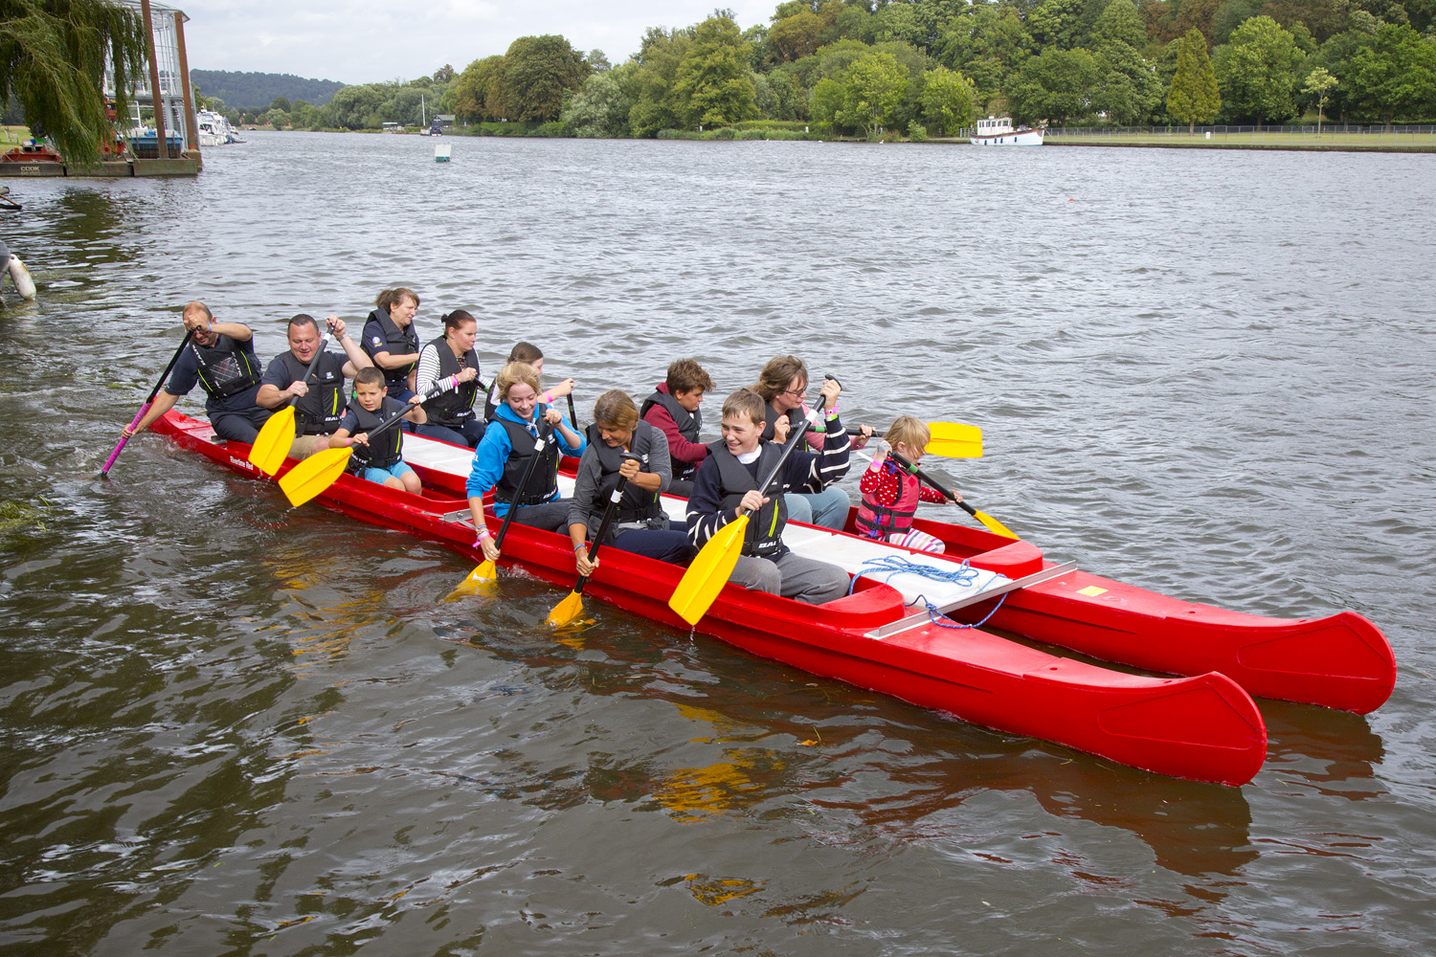

Bell Boating is a big part of the Regatta for Disabled each year and gives the opportunities for schools, charities and organisations to come together to have fun on the water and race against each other.

No experience is necessary as there will be a full briefing on the day of how to paddle and handle a Bell Boat.

Bell Boats accommodate teams of 10 paddlers and our qualified helm (the minimum number in a boat is 6 paddlers). The helm will be provided. We suggest you recruit crews of up to 13 for your team, although a maximum of only 10 crew members will race in the boat at one time, there will be plenty of opportunity to rotate the crew members during the Regatta. The minimum age in a team is 8 years and all paddlers must be able to swim in light clothing.

Teams need to arrive at 9.30am ready for the briefing at 10.00am with races starting at 10.30am. The final race will be at 2.30pm with the presentation of prizes at 3.30pm.

To enter a team there is a minimum donation of £100. Full payment is required to guarantee entry into the event, please see the entry form overleaf for payment details. A full briefing document will be provided before the Regatta.

Deadlines for entries is 1 August 2024.

Please complete one entry form per team

Team name (maximum 20 letters)

Representing

Contact Name Team Manager

Address

Postcode

Tel (work) Tel (home)

Mobile Email

How did you hear about the event?

Payment: I enclose my donation of £100.00 for ten team members. If you would like to make an additional donation, please complete the attached gift aid form.

Payment on-line: Beneficiary: Regatta for the Disabled Sort Code: 60 10 35 Account number: 13144529
Reference: Team name
Cheques payable to: Regatta for the Disabled. Please note that payment is required to guarantee entry into this event
Declaration
By signing this entry form I confirm my wish to enter a team into this event and confirm that I have read, understood and undertake to be bound by the Racing Rules and Regulations as outlined on page five of this document. I understand that I should advise my team members to seek medical advice from their general practitioner if they are in any doubt as to their physical ability to take part in this event. I acknowledge that all persons enter the Regatta at their own risk and that Regatta for the Disabled and Regatta for the Disabled will not be held responsible in any way for any accident, injury or loss that might occur prior to, during or after the event. I understand and give permission freely for photographs of the Regatta to be taken, some of which may be used for publicity purposes. I understand that Regatta for the Disabled and its associated companies (and companies processing data on its behalf) will hold and use the data provided by me in connection with this event for administration purposes, to keep me informed of its activities. Regatta for the Disabled and Regatta for the Disabled will take all reasonable steps to ensure that racing takes place as specified in the information pack. Regatta for the Disabled do however, reserve the right to delay, postpone or cancel the Regatta in the event of adverse weather conditions or other events outside of the organisers’ control. The entrance fee is non-refundable should your team have to withdraw from the event.

Signed Name Date

PLEASE RETURN COMPLETED FORM TOGETHER WITH PAYMENT TO:
Bell Boat Entries
Regatta for the Disabled
5 Elizabeth Road
Henley-on-Thames RG9 1RG
Email bellboating@regattaforthedisabled.org

Charity Gift Aid Declaration – single donation
If you are a UK Tax Payer and would like Regatta for the Disabled to benefit from the Gift Aid scheme please complete the Gift Aid form and include it with your entry:

Boost your donation by 25p of Gift Aid for every £1 you donate
Gift Aid is reclaimed by the charity from the tax you pay for the current tax year. Your address is needed to identify you as a current UK taxpayer.

In order to Gift Aid your donation you must tick the box below:

I want to Gift Aid my donation of £____ to: Regatta for the Disabled.

I am a UK taxpayer and understand that if I pay less Income Tax and/or Capital Gains Tax in the current tax year than the amount of Gift Aid claimed on all my donations it is my responsibility to pay any difference.

My Details:

Title ____________________ First name or initial(s) _______________________

Surname ____________________________________________________________

Full Home address ___________________________________________________

____________________________________________________________________

Postcode _________________________ Date ______________________________

Please notify the charity if you:

- Want to cancel this declaration
- Change your name or home address
- No longer pay sufficient tax on your income and/or capital gains

If you pay Income Tax at the higher or additional rate and want to receive the additional tax relief due to you, you must include all your Gift Aid donations on your Self-Assessment tax return or ask HM Revenue and Customs to adjust your tax code.

